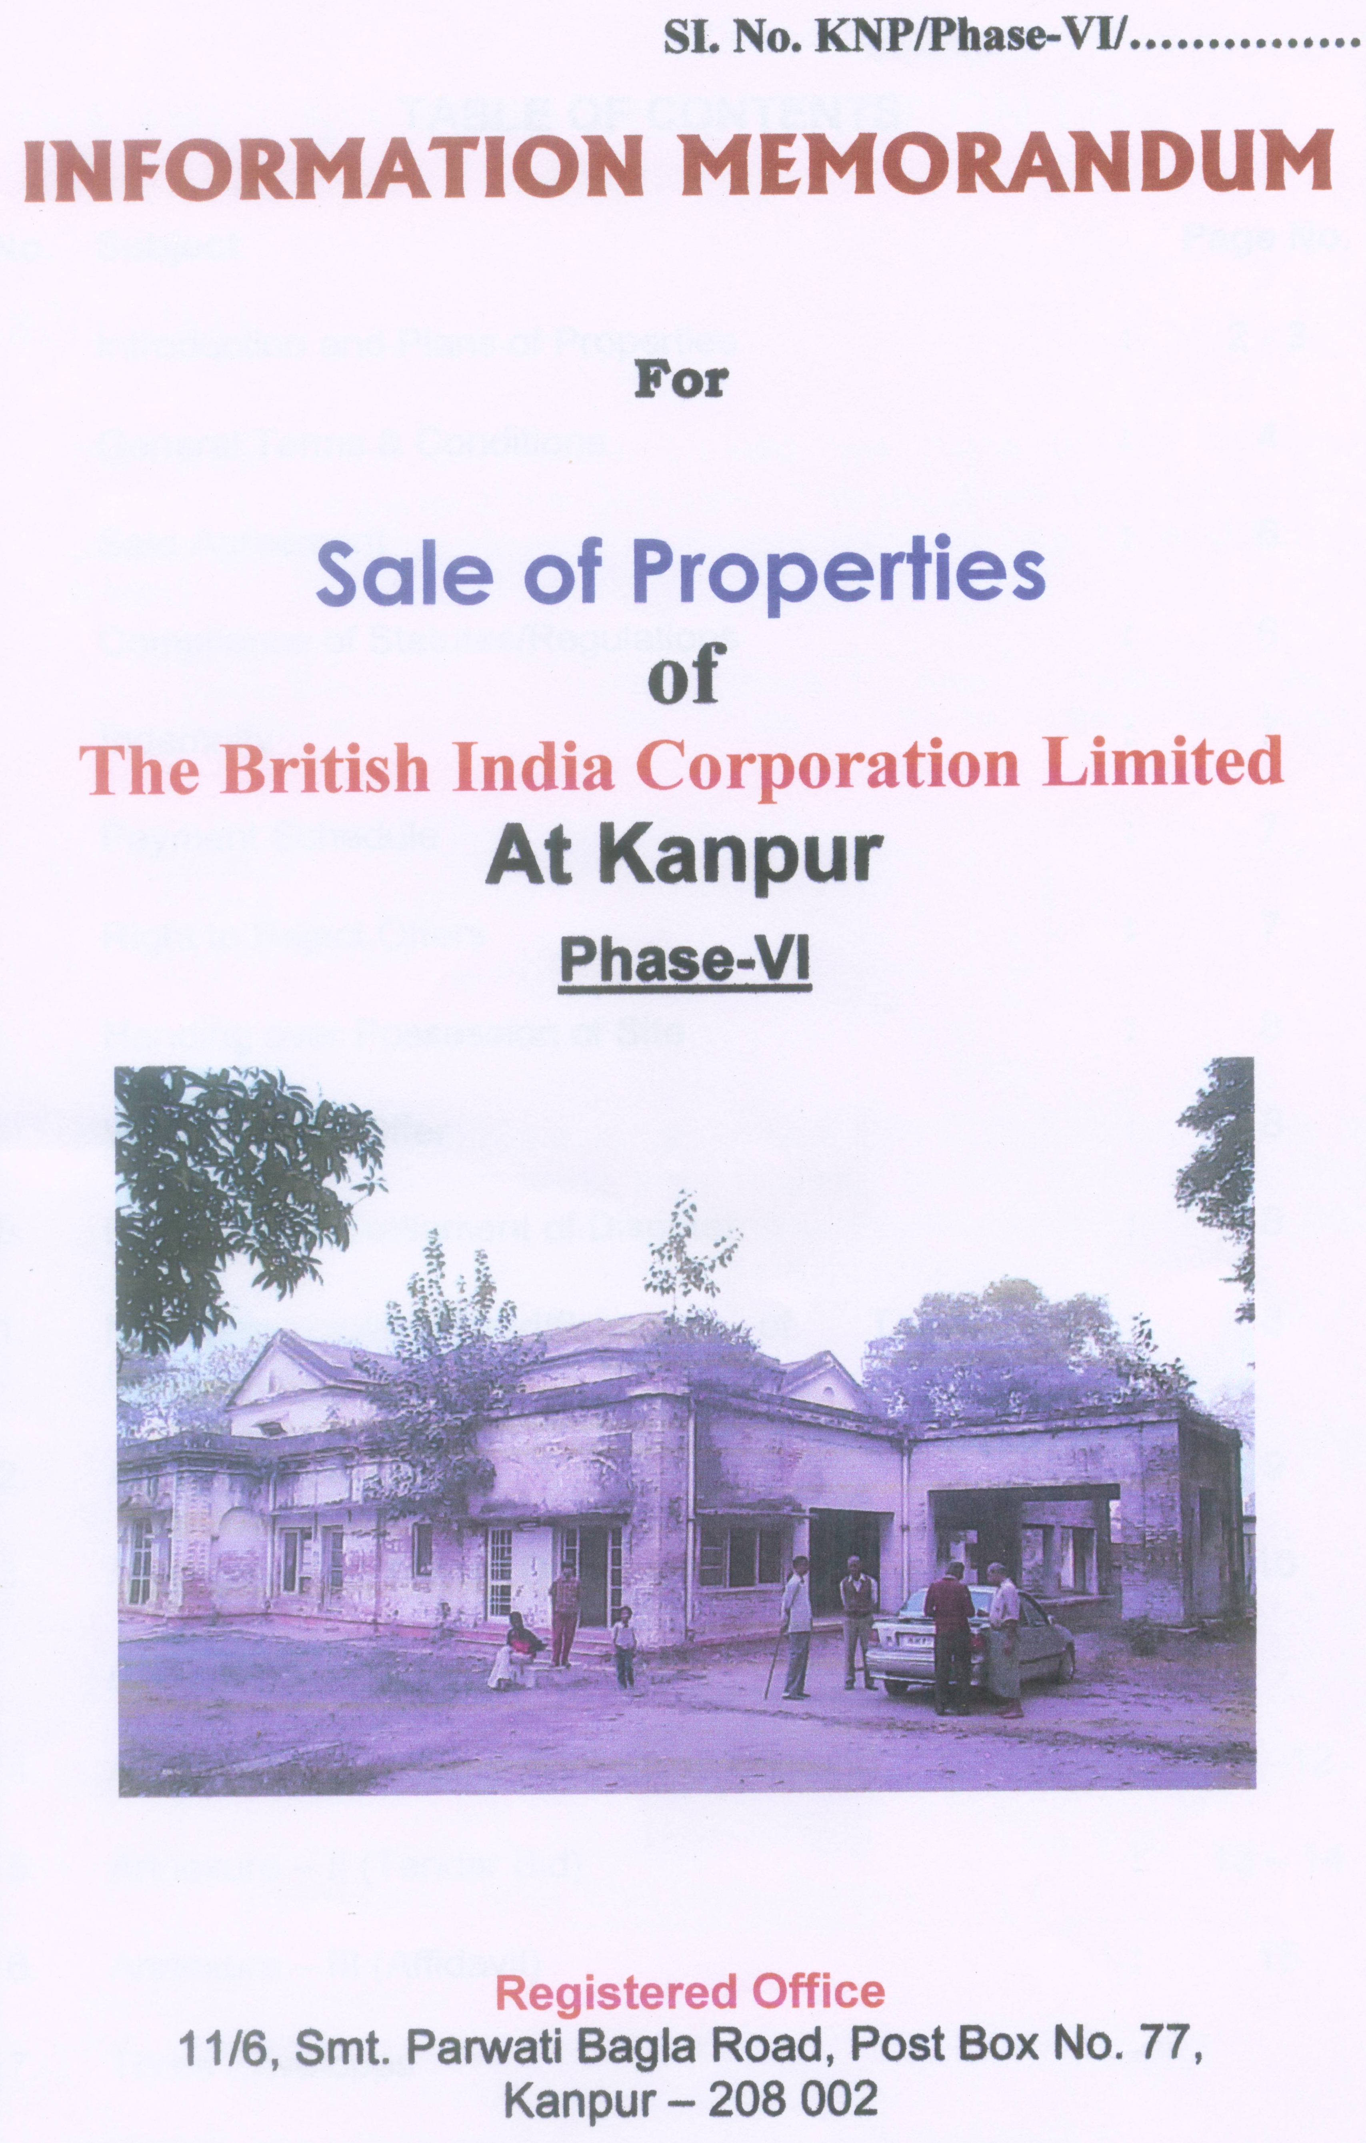
TABLE OF CONTENTS

Sl.No. | Subject |  | Page No.
 | Introduction and Plans of Properties | : | 2 - 3
 | General Terms & Conditions | : | 4
 | Sale Agreement | : | 6
 | Compliance of Statutes/Regulations | : | 6
 | Indemnity | : | 7
 | Payment Schedule | : | 7
 | Right to Reject Offers | : | 7
 | Handing over Possession of Site | : | 8
 | Withdrawal of Offer | : | 8
 | Provision for Settlement of Disputes | : | 8
 | Misrepresentation/Fraud/Breach of Terms & Conditions | : | 8
 | Acceptance of offers | : | 9
 | Amendment of Tender Document | : | 10
 | Annexures
14. | Annexure – I (Letter of Application & Intent) | : | 11 -12
15. | Annexure – II (Tender Bid) | : | 13 – 14
16. | Annexure – III (Affidavit) | : | 15
17. | Three Envelopes
THE BRITISH INDIA CORPORATION LIMITED
KANPUR

INTRODUCTION

1.1 The British India Corporation Limited has plans to sell following Properties / bungalow of the Company. This document is meant for sale of land and building situated at Kanpur (UP) on “AS IS WHERE IS BASIS”:-

Sl.No. | Name & Municipal Number of property | Plot No. | Block No. | Area  Sq. Mt. | Build-up Area in Sq. Mt. | Trees/ Teaks
1. | Park House/Park Lodge,  14/89 and 14/90 Civil Lines, Kanpur. | 18 | 14 | 9730.76 | 2141.27 | 32 trees

  - Location of Property

Property situated at prime location i.e near UPFC Civil Lines Kanpur. It is approximately 4 km away from Railway Station and nearest from Hospitals, Markets etc. It has two bungalows and servant quarters. This land has huge garden adjacent to the main building.

  - Existing Position

The aforesaid land is perpetual lease hold property (999 years) with residential land use and free from all encumbrances.

  - Earnest Money

The amount of Earnest Money to be paid along with offer as under:-

Sl. No. | Particular of the Property | Earnest Money
1. | Park House/Park Lodge,  14/89 and 14/90, Civil Lines, Kanpur | Rs. 2.30 Crores

As far as payment of EMD refer Clause No.2.5.

SITE PLAN

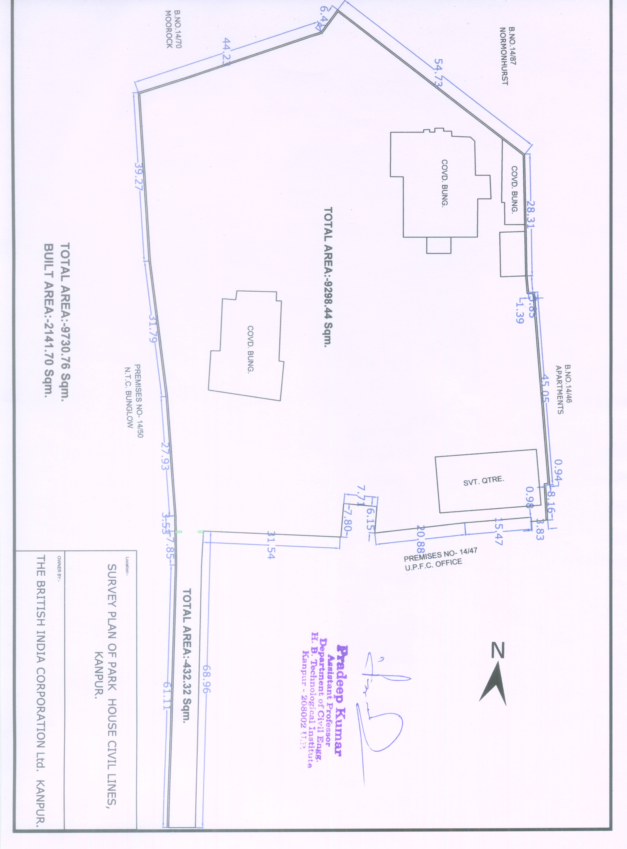
2. GENERAL TERMS & CONDITIONS

  - Eligibility Conditions

The tenderer should:
- be any person, registered trust, registered firm, and registered cooperative society, private limited company registered in India.

- be legally competent to enter into contract as per prevailing laws.

- Income Tax Assessment Orders for the last three years would be required.

The BIC Ltd. MAY ALSO CONSIDER a bid submitted by a CONSORTIUM OF PERSONS/COMPANIES. It is, however, made clear that there should be no change in the consortium structure during the finalisation of the tender right up to the stage of depositing the full bid amount with BIC Ltd. If there are any changes in the consortium structure, BIC Ltd reserves the right to cancel the sale. However, the financial arrangement between the parties should be specified in the tender document. No bid by a Consortium/Partnership Company shall be entertained if in the opinion of the Asset Sale Committee, it has led to reduction in competition.

  - Inspection

Bidders will be allowed to inspect the assets and other related documents on stipulated dates (between 06.02.2008 to 29.02.2008) in the presence of officials of company to enable them to do their due diligence. Bidders are also advised to check and verify the title and other details of the property in the Nazul Department of Collectorate, Kanpur.

  - Clarification

A prospective bidder/tenderer requiring any clarification of the bid document may notify the Corporation and the Corporation will respond in writing to any request for clarification which it received not later than 10 days prior to the dead line for submission of the bids. A copy of the response then would be sent to all prospective bidders/tenderers.

  - Opening of Tenders

Tenders will be opened in the Board Room of the B.I.C. Ltd, 11/6, Smt. Parvati Bagla Road, Kanpur in the presence of Tenderers who wish to remain present at 3.00 p.m. on 01.03.2008.

  - Earnest Money Deposit (EMD)

The bidder should deposit the Earnest Money as specified in clause 1.4 above, by means of a Bank Draft drawn on a Nationalised Bank in favour of The British India Corporation Limited, payable at Kanpur, in respect of the property. The EMD should be in a sealed cover marked “Earnest Money Deposit for Park House/Park Lodge, 14/89 and 14/90, Civil Lines , Kanpur”. This amount shall be forfeited, if the party whose offer/bid is finally accepted defaults in making the balance payment in terms of the conditions of sale including failure to complete other sale formalities within the due date. If, however, the sale is completed within the specified time limit, the EMD shall be adjusted towards the final sale price. In case of unsuccessful bidders, Earnest Money will be returned within 14 days of the opening of the tender. No interest will be paid on the EMD.

  - Procedure for selecting successful tenderer

i) a) The sealed offers will be opened in the presence of Tender Opening Committee and / or the Asset Sale Committee of the Company. All original documents will be signed by Members of the ASC in whose presence the tenders are opened.

b) The offers shall be opened in the presence of authorised representative of bidders who may remain present and their presence shall be recorded with their signatures. The price quoted shall be read out to all present, subject to verification of other contents of the offers. Mere reading out the price shall not be construed that the offer is valid or acceptable.

- Soon after opening the bids, Member Secretary of the ASC shall prepare a ‘Comparative Chart’ of the offers received and along with all relevant details, place the same before ASC. The meeting of ASC should be held preferable within 10 days after the opening of tenders, so as to take expeditious decision on disposal of properties.

- After opening of the sealed offers, in case highest valid offer is found to be lower than the ‘Reserve Price’, the Assets Sales Committee will give all the valid tenderers an opportunity to improve upon their offers and such revised offers shall be submitted in sealed covers at the date and time fixed within 15 days of the opening of the original tenders. Such revised offers will be opened on a notified date, time and place by the Tender Opening Committee in the presence of the representatives of the tenderers. In such a case, the tenderers would be only allowed to increase their offer and shall not be allowed to reduce the same. In case any offer is lowered, the EMD paid with the original offer shall stand forfeited. In case no revised offer is received from a tenderer it will be presumed that the original offer is the final offer. A Comparative Chart of the offers shall again be prepared by Member Secretary and put up to the ASC for decision. In case there is no upward revision of the offers, the matter will be placed before ASC to decide about further course of action.

- All Tenderers shall keep their offer valid for acceptance by BIC Ltd for a period of 30 days from the date of opening of financial bid. If any Tenderer withdraws his offer within the period of
thirty (30) days, EMD paid by him shall be forfeited.

3. SALE AGREEMENT

  - Execution of Sale Deed

(i) The Company will execute the sale deed in favour of the purchaser simultaneously on receipt of full amount of the bid.

- The Sale deed shall be executed with the buyer specifying therein all the terms and conditions related to the sale of property of the company. The “Conveyance Deed” shall be executed with the buyer, the documents will be duly registered and the possession of the property purchased and the title thereof shall be transferred to the buyer only on receipt of full payment of purchase consideration along with interest in case of delayed payment, if any.

- Sale deed will be subject to jurisdiction of the Court where property is situated i.e. at Kanpur.

- All Costs, charges, taxes, if any and expenses incidental to and in relation to the sale including the cost of and incidental to the sale agreements and other writings, if required to be made in pursuance thereof, stamp duty, registration fee, other charges etc, shall be borne and paid by the purchaser alone.

4. COMPLIANCE WITH STATUES/REGULATIONS

    - Purchaser shall comply with all Statutory Provisions, Rules & Regulations, Bye-laws, etc. in all respects, including paying all fees, taxes in accordance with the provisions of:-

- Any Central or State enactment, Ordinance or other Statute, or any regulation or by law or any local or other duly constituted authority.
- The rules and regulations of all public bodies and companies whose property or rights are affected or may be affected in any way.

5. INDEMNITY

5.1 The intending purchaser shall indemnify BIC Ltd. against all actions, suits, claims and demands brought or made against it in respect of any thing done or omitted to be done by the intending purchaser in execution of, or in connection with the work of the Agreement and against any loss or damage to the Corporation in consequence or any action or suit being brought against Corporation for any thing done or omitted to be done in the execution of this Agreement.

6. PAYMENT SCHEDULE

6.1 Payment schedule will be as follows:-

1st instalment | 2nd instalment
25% within 15 days of issue of acceptance letter by BIC Ltd. over and above EMD | Additional 75% within 60 days of issue of acceptance letter by BIC Ltd. EMD shall be adjusted against this second and last instalment.

  - The date of intimation of acceptance shall be the date on which intimation regarding the final acceptance of the bid is dispatched to the Purchaser by Registered A.D. post/speed post/Courier at his notified address. In case of delayed payments, as specified in payment schedule, interest @ SBI Prime Lending Rate + 4% p.a. will be chargeable, for such delay. Extension in payment schedule shall be at the sole discretion of ASC but not exceeding 60 days in any case.

  - If the purchasers do not pay the balance of the purchase money in the manner and within the date & time specified, the Asset Sale Committee shall be at liberty to forfeit the earnest money and any other deposits made and proceed to resell the property.

7. RIGHT TO REJECT OFFERS

The right to accept or reject any or all offers without assigning any reason is reserved. The right of negotiations with the highest bidder is also reserved.

8. HANDING OVER OF POSSESSION OF SITE

Possession of the subject site to the tenderer shall be handed over shall be handed over simultaneously with receipt of full amount.

9. WITHDRWAL OF OFFER

In case the successful tenderer withdraws his offer subsequent to its being accepted by the Assets Sale Committee, any payment made by the tenderer including EMD would be forfeited by BIC Ltd.

10. PROVISION FOR SETTLEMENT OF DISPAUTES

In case of any dispute between the parties in respect of interpretation of the terms of this Tender Document or anything arising out of bid such dispute or difference shall be referred to the Chairman, Asset Sale Committee, BIC Ltd. He shall be empowered to adjudicate and decide the disputes, if any, between the parties and his decision shall be final, conclusive and binding on both the parties.

11. MISREPRESENTATION / FRAUD / BREACH OF TERMS & CONDITIONS

If it is discovered at any point of time that the Tender/Purchaser has purchased the land by suppression of any fact or mis-statement or misrepresentation or fraud or if there is any breach of the conditions of the tender or violation of any of the terms of the sale deed, the sale may be cancelled by the BIC Ltd. In such an event, Tenderer/Purchaser will not be entitled to any compensation whatsoever, or refund of any earnest money or any other amount paid by him.

NOTES:
1 Canvassing in connection with the tenders is strictly prohibited and the tender submitted by the tenderer who resorts to canvassing shall be rejected summarily.

2. Tenderer shall not add any new condition or delete any condition from the offer. The offer shall be submitted in the form as it is. Any conditional offer is liable to be rejected summarily.

3. An offer must be made by filling in the enclosed tender forms separately which must be completed in all respects and all the documents required must be enclosed. Incomplete offers shall be rejected summarily.

12. Acceptance of the offer

- The bidder shall submit the offer in an envelope (enclosed) marked Bid offer for (Park House/Park Lodge) along with requisite EMD draft drawn on nationalized bank in favor of BIC Ltd. Kanpur in other envelope (enclosed) marked "EMD". Both the envelopes along with terms and conditions duly signed on each page should be put in one big envelope (enclosed) and marked "Tender for Park House/Park Lodge, and submitted in the tender box, kept in the office of G.M.(P&A), BIC Ltd. Kanpur at any working day from 05.02.2008 to 01.03.2008 (3.00 PM).

- First the envelope containing EMD shall be opened and after verification for correctness in terms of amount and bank the envelope containing bid shall be opened by the committee and read out.

- The offers of all the bidders shall be placed before the Asset Sale Committee for consideration.

- The decision of the Asset Sale Committee in this matter shall be final.

- The Asset Sale Committee reserves the right to reject any tender. The decision of the Asset Sale Committee in this respect will be absolute. The Asset Sale Committee may for reasons to be recorded in writing, reject any tender including the highest tender. The Asset Sale Committee would not be obliged to give a copy of reasons for rejection of the bid to the unsuccessful tenderer.

- After approval of the acceptance of tender by the Asset Sale Committee, the tenderer shall be informed of the same in writing.

- Within 15 days of the opening of the financial bid, the Office of BIC Ltd. shall communicate to the tenderers, whose names have been short-listed.

- BIC Ltd shall return the EMD received from the tenderers who do not qualify or fail to get short-listed within 15 days of the opening of the tenders. The EMD shall be returned without any interest on the same.

- EMD received from all the short-listed tenderers shall be retained by BIC Ltd. till the finalization of the successful bidder by Asset Sale Committee. BIC Ltd. shall not en-cash the EMD from any of the tenderers, except that of the successful bidder in whose case, EMD without any interest payable on the same, shall be adjusted against 2nd and last installment. In the case of other short-listed bidders, the EMD will be returned within 15 days of the finalization of bids by ASC.

- Within 15 days of the meeting of the ASC, a letter will be written by BIC Ltd. to the successful bidder to deposit the 1st installment as per schedule.

13. AMENDMENT OF TENDER DOCUMENT

- Any time prior to the last date for submission of the tender documents, BIC Ltd. for any reason, whether on its own initiative or in response to a clarification requested by a prospective bidder, may modify the bid document by amendment.

- All prospective bidders that have received bid document will be notified of the amendment in writing or by a cable at the address provided by them and the same will be binding on them

ANNEXURE - I

Letter of Application & intent

(Letter-head of the Applicant including full Postal address, Telephone NO./Fax No./Mobile No./Telex/E-mail/Cable address)

Dated:……………………….

TENDER FORM SR. No. KNP/Phase-VI/PL/

To,

The Member Secretary,
Asset Sale Committee,
The British India Corporation. Limited,
11/6, Smt. Parvati Bagla Road,
KANPUR – 208 0012

Sub: Tender for purchase of ‘Park House/Park Lodge’, 14/89 & 14/90, Civil Lines, Kanpur

Sir,

1. Being duly authorized to represent and act for and on behalf of M/s.___________________________________________________, and having studied and fully understood all the information provided in the tender document, the undersigned hereby apply as a tenderer for purchase of
Park House/park Lodge, 14/89 & 14/90, Civil Lines, Kanpur admeasuring
9730.76 Sq Mtrs along with build-up area admeasuring 2141.27 Sq Mtrs and valuable trees/teaks according to the terms & conditions of the offer made by BIC Ltd.

2. Financial Bids are given in Annexure-I along with the attachments, duly filled and signed on each page. The same are put in an envelope marked “Tender Bid for sale of Park House/Park Lodge, 14/89 & 14/90, Civil Lines, Kanpur”.

3. Demand Draft / Pay Order towards the Earnest Money Deposit is enclosed in the envelope marked “Earnest Money Deposit for purchase of
Park House/Park Lodge, 14/89 and 14/90, Civil Lines, Kanpur”.

4. BIC Ltd. and its authorized representatives are hereby authorized to conduct any inquiries / investigation to verify the statements, documents and information submitted in connection with the application and to seek clarification from our Bankers regarding any Financial and Technical aspects. This letter of application will also serve as authorization to any individual or authorized representative of any institution referred to in the supporting information, to provide such information deemed necessary and requested by yourselves to verify statements and information provided in the application or with regard to the resources, of the Applicant.

5. BIC Ltd. and its authorized representatives may contact the following persons for any further information

Name of the Person/s: _______________________________________
Address: __________________________________________________
Telephone No._______________ Mobile No._____________________
Fax Number: __________________

6. The application is made with full understanding that:

- Tenders will be subject to verification of all information submitted at the time of tendering.
- Asset Sale Committee, BIC Ltd. reserves the right to reject or accept Any Tender, cancel the tendering process, and /or reject all Tenders.
- Asset Sale Committee, BIC Ltd. shall not liable for any of the above actions and shall be under no obligation to inform the applicant of the same.

7. We, the undersigned declare that the statements made, and the information provided in the duly completed application forms enclosed, are complete, true and correct in every detail.

8. We have read the terms & conditions of the offer detailed in the tender document and are willing to abide by them unconditionally.

9. The offer made by us is valid for 30 days.

Signature: ________________________  For and on behalf of  ________________________  (Name of Applicant ) | Signature: ________________________  For and on behalf of  _______________________  (Name of Applicant)

Enclosure:-

- Tender Bid – Annexure-I
- Affidavit – Annexure –II along with Power of Attorney (as applicable)
- Documents pertaining to information given in the tender.

ANNEXURE – II

TENDER BID

Tender Form Sl. No.:
The Member Secretary,
Asset Sale Committee,
British India Corporation Limited,
11/6, Smt. Parvati Bagla Road,
Post Box No.77,
KANPUR – 208 002

1) | Particulars of the Applicant
 | 1.1 | Full name of the Applicant  (use block letters)
 | 1.2 | Whether the tenderer is Competent to contract under Indian Contract Act, 1872 as per Foreign Exchange Regulation Act, 1973/Foreign Exchange Management Act, 1999 in case of NRI  (Tick whichever is applicable) | YES / NO
2) | Constitution of Applicant)  (Tick whichever is applicable) |  | Public Limited Company  Private Limited Company  Partnership  Individual / Sole Proprietary  Others (specify)  Furnish documents in support)
 | 2.2 | Applicant’s registered office/ place of business  - Address  -Telephone No.  - Mobile No.  - Fax No.  -E-mail address

3. | Particulars of Tender
 | 3.1 | The price offered is for  - Park House/Park Lodge, 14/89 and 14/90,Civil Lines, Kanpur. | Rs.________________ (in figures)  Rupees…………………………….  ……………………………………..  ……………………………………..  (in words)
 | Certified that:

 | i) | In case our offer is accepted and if we fail to pay the amount in the manner to be specified by BIC Ltd. in the “Letter of Acceptance”, the amount of Earnest Money paid by us under this offer shall stand absolutely forfeited to BIC Ltd.
 | ii) | The offer is valid for a period of one month from the date of opening of the Financial Bid.
 | iii) | I / We agree to abide by the decision of the Asset Sale Committee, BIC Ltd.
 | iv) | I / we have read and understood terms and conditions of the tender as well as those contained in the proforma of the Sale Deed and hereby unequivocally and unconditionally accept the same.
 | v) | I / We inspected the site / relevant documents for which tender is being submitted.
4 | We hereby declare that the information stated hereinabove is complete and absolutely correct and any error or omission therein, accidental or otherwise, will be sufficient justification for the Authority to reject our tender and / or to cancel the award of sale.

Dated: ___________

Applicant’s signature :

Full Name :

Designation :

Name of the Company :

Address of the Company :

ANNEXURE – III

AFFIDAVIT

(To be given separately by each constituent of the tenderer on Stamp of Rs.10/-)

I, ………………………………………….., son of …………………………… resident of ……………………………………………………………………….. having been duly authorized to make this statement do hereby state as under:-

That whereas, I have tendered for the Park House/Park Lodge, 14/89 and 14/90, Civil Lines, Kanpur.

Now, therefore, I, the undersigned, do hereby certify that all the information supplied is accurate, true and correct.

The undersigned also authorize(s) and request(s) any Bank, person or firm to furnish any information requested by BIC Ltd. to verify any pertinent information deemed necessary and our reputation.

The undersigned also understands and agrees to supply any further information as may be requested by BIC Ltd.

The undersigned also understands that furnishing of false information could result in disqualification of his company for the award of Sale contract.

(Signed by an Authorised Signatory of the Firm / Individual):……………………..

Title of Officer: ……………………………………………………..
Name of the Firm: …………………………………………………
Date: ………………..

Encl: Requisite Power of Attorney.

ANNEXURE-III

DRAFT SALE DEED

(On stamp paper – Stamp duty as applicable)

THIS INDENTURE of sale deed made on the ………….. day of …………………
the year Two Thousand and Eight between The British India Corporation Limited having its registered office at 11/6, Smt. Parvati Bagla Road, Kanpur hereinafter called the Vendor (which expression shall include wherever applicable its successors, executors, legal representatives and assignees) of the ONE PART AND Shri …………………………………………………. son of Shri ……………………………………………. resident of …………..……………… ……………………………………………………. hereinafter called the Vendee (which expression shall include wherever applicable his heirs, executors, legal representatives, successors and assignees) of the OTHER PART.

WHEREAS, BIC Ltd. had by means of deed dated 19 had acquired the said estate which was commonly known as Park House/Park Lodge. Current Municipal Number of the property is 14/89, 14/90, Civil Lines, Kanpur.

AND WHEREAS the Vendor herein has become perpetual leased owner of the total extent of 9730.76 Sq Mtrs and the building constructed thereon more fully described in the Schedule hereunder; and …………………………………………

AND WHEREAS the Vendor has offered to sell the said 9730.76 Sq Mtrs of land bearing Plot No. ……………………………… (part) situated at Kanpur known as ………………………… ……………. together with a building bearing Municipal No. 14/89, 14/90, Civil Lines Kanpur, and invited tenders and the Purchaser has agreed to purchase the said property more fully described in the schedule hereunder and delineated in the plan attached hereto and coloured …………………. thereon for a total sale consideration of a sum of Rs.…………………………… (Rupees ………………………………......… ……………………………………………………………………….. Only) for which the tender of the Purchaser was accepted by the Vendor vide letter No.………………………… dated ………………………………

NOW THIS INDENTURE OF SALE WITNESSESTH AS UNDER:

That in pursuance of the said agreement and in consideration of the said sum of Rs. …………………. (Rupees ……………………………………………….. ……………………………………………………………………………………...only) paid by the Purchaser herein unto the Vendor before execution of these presents (the receipt of which sum the Vendor both hereby acknowledge as the full consideration) the Vendor doth hereby grant, covey, and assign by way of transfer of lease unto the Purchaser for balance period of lease along with all those pieces and parcel of land admeasuring …………….. Sq Mtrs bearing plot No. …………………………….popularly known as ………………………….. situated ………………………..along with the building constructed thereon bearing municipal No……………., more fully described in the schedule herein and delineated in the plan attached thereto and coloured ……………… thereon together with building fixtures etc. with all the estate, right, title and interest of the Vendor herein together with all other right, easements, advantages, privileges and appurtenances whatsoever in the said piece and parcel of land to have and to hold the same unto the Purchaser herein for balance period of lease and from the date of execution of this title deed pay all encumbrances, claims, demands, attachments and charges of all claim but subject however to the payment of all Government assessment and other taxes payable to the Government of any other Local Authorities in respect of the said land and property more particularly described in the Schedule hereunder the delineated in the plan attached hereto and coloured ………………….. thereon together with all ways, waters, water curses thereto, whatever in the said piece or parcel of land more full described in the schedule hereunder and hereby conveyed, the Vendor covenant and confirm that all rents, rates, taxes, assessment dues, duties on the said property have been paid by them up to and including the date of these presents and further covenant that should any rates, taxes, dues and duties be found payable up to date, the same shall and will be paid by him; and

AND WHEREAS the Vendor doth hereby covenant with the said purchaser that he, the Vendor have right, title, interest and full power to grant, convey and assign the said piece and parcel of property more particularly described in the schedule hereunder and delineated in the plan attached hereto and coloured ………………… thereon in the manner aforesaid and that the said property is free from all encumbrances, claims, demands and other court attachments and that the purchaser may quietly enter into and enjoy the same, the rents and profits of the said property without any lawful interruption, claims, demand or disturbance whatsoever from the said vendor or any other person or persons claiming through, under or in trust for the said vendor. And that free and clear and freely and clearly and absolutely acquitted, exonerated, released and forever discharged or otherwise by the vendor and sufficiently saved, defended, kept harmless and indemnified of, from and against all former and other estates, titles and charges and / or encumbrances whatever had made, executed, occasioned or suffered by the vendor or by any other person or persons lawfully or equitably claiming or to claim by, from, under or in trust for them or any of them with the vendor and all persons having or lawfully or equitably claiming any estate, right, title or interest in law or in equity in all said property hereby assigned, transferred or any part thereof by, from or in trust for the vendor or his successors, assigns and representatives shall and will from time to time.

AND the Vendor doth hereby covenant with the purchaser that notwithstanding any act, deed, matter or thing whatsoever by the vendor or by any person or persons lawfully or equitably claiming by, from, through, under or in trust for him, made, done, committed or knowingly or willingly suffered to the contrary, has right, title or interest to the said property not becoming void or avoidable or the vendor doth hereby covenant with the purchaser that there is no mortgage, charge or lien or other encumbrances on the said property and the vendor doth hereby further covenant with the Purchaser that the Purchaser, its visitors, servants, agents and licensees from time to time and at all times hereafter by day and night at its or their free will and pleasure for all purposes connected with the use and enjoyment of the said property hereby conveyed, and assured or expressed so to be to go to return, pass and re-pass with or without vehicles of all descriptions (including mechanically propelled vehicles) laden or unladen and with or without animals over the common road and the Vendor declare that he has handed over to the Purchaser all documents of title relating to, belonging to or connected with the said property and the Vendor declare and confirm that he does not have any other documents of title and should be come in possession of any evidence or document of or relating to title, he shall and will hand over or cause to be handed over to the Purchaser or any person claiming through or under the Purchaser.

AND, lastly the Vendor doth hereby confirm that he had handed over to and placed the Purchaser in possession of the said property hereby granted, conveyed, transferred and assigned unto the Purchaser.

IN WITNESS WHEREOF the Vendor has hereunto set his hand to this indenture of sale on the day, moth and year first above herein written

SCHEDULE OF THE PROPERTY ABOVE REFERED

All that piece or parcel of land or ground bearing plot no. …………………. (part) situated at Kanpur admeasuring ……………. Sq. Mtrs. or thereabouts along with the building bearing Municipal No. of popularly known as ……………….. marked ……………… and delineated by the ……………. colour in the site plan annexed thereto, within the Registration District Kanpur and bounded as follows:

MODEL DRAFTS

NORTH:

SOUTH:

EAST:

WEST:

WITNESSES:

1. Signed and delivered by

2.
……………………………………………………
(for and on behalf of the within named Vendor)

Dated
Signature and delivered by

…………………………………………………….
For and on behalf of

Last date for submission of Tenders for the sale of Park House and Park Lodge is extended upto 12.00 noon, 24 .3. 2008 and shell be opened on the same day at 12.30 p.m.

